X Mind
Contents
Introduction to Concept Mapping 2
Concept Mapping and the Specific Learning Differences Dyslexia and Dyspraxia 2
Using XMind for Concept Mapping 2
Getting Started with XMind 2
Changing the properties of your XMind map 3
Add a hyperlink 4
Add an image 5
Add notes to a topic 5
Move a topic 5
Exporting your map to Microsoft Word 6
Exporting your map as an image 6
Writing Lesson Plans using Concept Mapping 7
Step 1: Brainstorming 7
Step 2: Rationalise your Activities 7
Step 3: Sequence your Activities 8
Step 4: Rationalise your Activities Again 8
Step 5: Plan your Transitions 8
Step 6: Plan your Introduction 8
Step 7: Plan your Conclusions 8
Step 8: Your final plan 9
Sample Lesson Plan: Polarity of Magnets 9
References 11

Introduction to Concept Mapping
X Mind is free (open source) software for concept mapping which is a technique to visually illustrate relationships. Concept maps begin with a main idea (or concept) and then branch out to show how that main idea can be broken down into specific topics so they can be used to organise and represent knowledge of a subject.

Concept Mapping and the Specific Learning Differences Dyslexia and Dyspraxia
In their book ‘The Dyslexic Advantage’, Brock and Fernette Eide discuss the dyslexic processing style where they suggest that dyslexic processing predisposes individuals to important abilities as well as creating challenges with certain academic skills. These abilities may include:
- Three-dimensional spacial reasoning
- The ability to perceive subtle relationships and patterns
- The ability to understand abstract information in terms of specific examples
(Eide & Eide, 2011:5)
Concept mapping makes use of these abilities to address the challenges faced with organisational skills and academic writing and it can be used for:
- Brainstorming and generating new ideas
- Identifying the key concepts for further elaboration
- Moving from a holistic view of a concept to a linear format for academic writing
- Drafting, planning and organising written work
- Integrating new concepts with older concepts

Using XMind for Concept Mapping

Getting Started with XMind
You can access XMind on the Institute of Education student network by clicking on the arrows next to ‘Accessibility’ at the bottom right hand of your screen on the task bar.
You can also download and install XMind for free on your home computer at http://www.xmind.net/downloads/ where it is also possible to upgrade to XMind Pro for more advanced features.
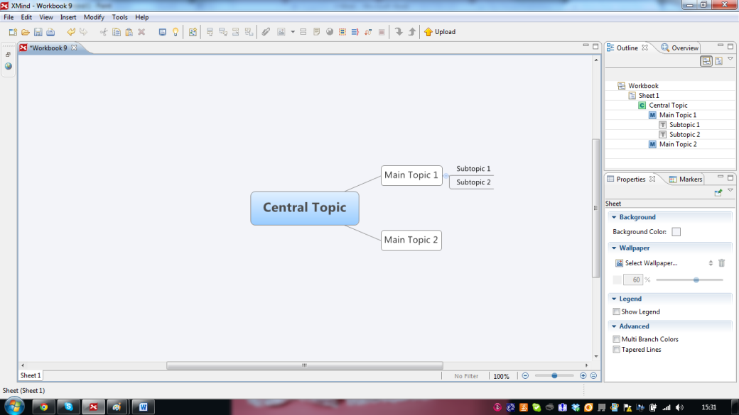
Written instructions for using the basic features of XMind are shown here but there are many videos on YouTube which explain both basic and more advanced concepts including collaborative facilities.

- Click inside the central topic and type in a title or the main objectives or your project
- Select the central topic and choose insert on the menu and select topic, type in your first idea or heading
- Continue selecting your central topic and adding the main topics of your concept map
- To add a sub-topic, select a main topic and choose insert on the menu and select sub-topic

Changing the Properties of your XMind map
Use the properties panel on the bottom right hand side of the screen to change the structure, shape, background colour, font size or font colour for each topic
- Select one topic
- Select the property you would like to change from the properties panel
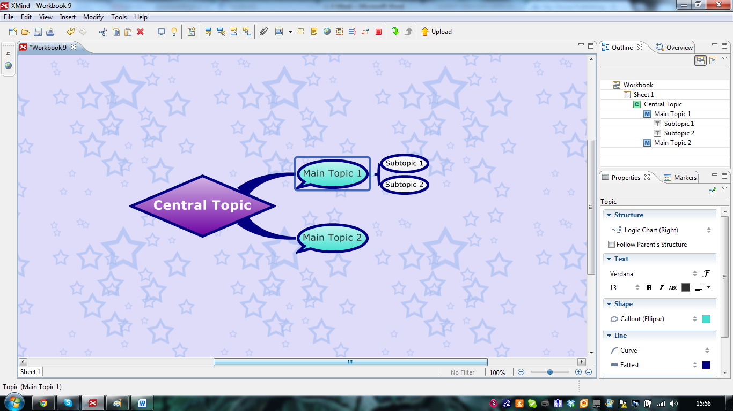

Add a hyperlink
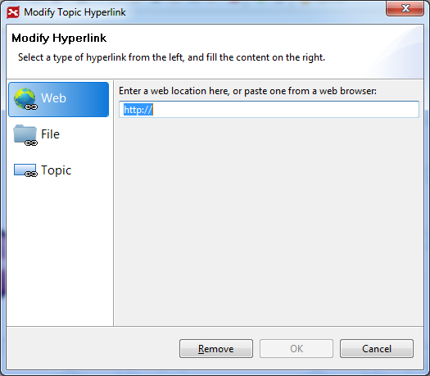
- Select the topic to which you would like to add a hyperlink
- Click the hyperlink icon on the toolbar
- A pop-up window will appear – enter the URL in the textbox
- Click OK
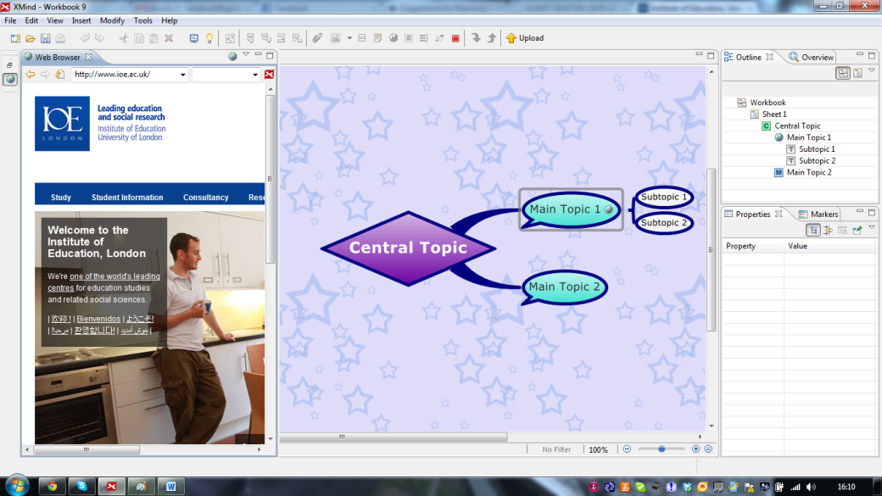
When you click on the internet link, a browser page will appear in the same window as your concept map.

Add an image
- Select the topic where you would like to add the image
- Choose insert on the menu and search your files to locate a saved image or drag and drop from a web page.

Add notes to a topic
- Select a topic
- Select modify and notes
- Type the extra information into the pop-out notes dialogue box
- Click anywhere on the map to close the box
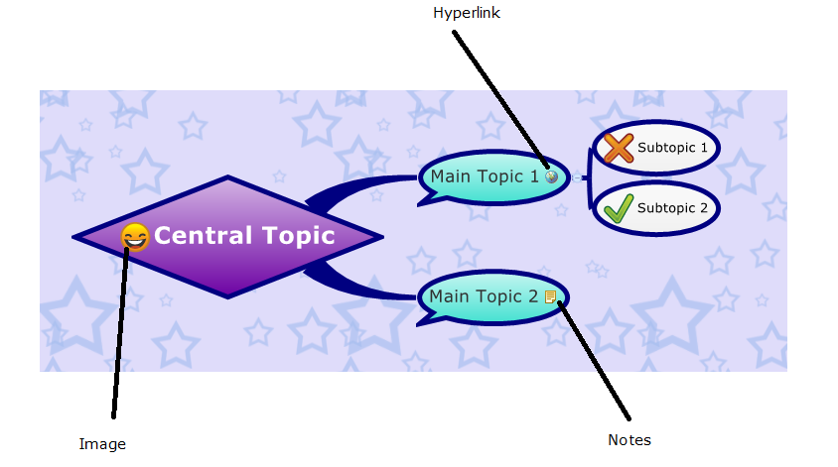

Move a topic
- Select the topic you wish to move
- Hold the left mouse button down whilst you move it to the correct position
It is possible to change the order of your topics or change a topic to the sub-topic of a different topic

Exporting your map to Microsoft Word
This is an easy process in the XMind Pro but can also be done in the free version:
- Select File > Export
- Select TXT File in the export dialogue box
- Click Next to continue
- Choose the location to save the document by clicking Browser
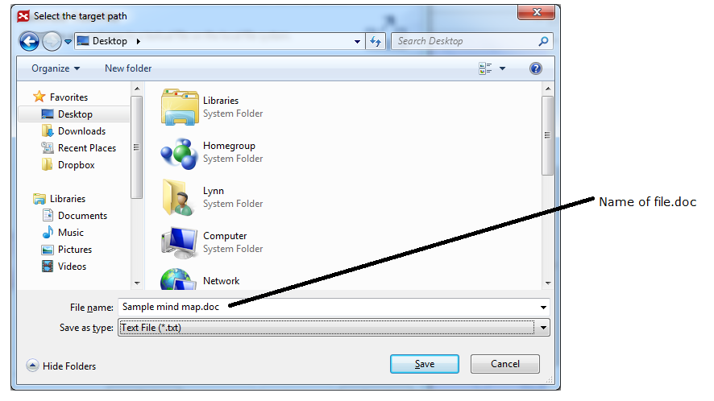
- Type in the file name with the extension .doc
- Click Finish

Exporting your map as an image
- Select File > Export
- Select Image in the export dialogue box and then next
- Images can be exported in BMP. JPEG, GIF and PNG formats

Writing Lesson Plans using Concept Mapping
Many people with dyslexia and dyspraxia describe excellent problem-solving skills which come from the ability to perceive a situation from multiple perspectives. This has the great advantage of being able to think of numerous approaches to help a student who is struggling with the approach that suits the majority of the class but can cause problems in developing lesson plans from scratch when there are so many possible activities to use.
See also Allen et al. (1993) and Martin (1994)

Step 1: Brainstorming
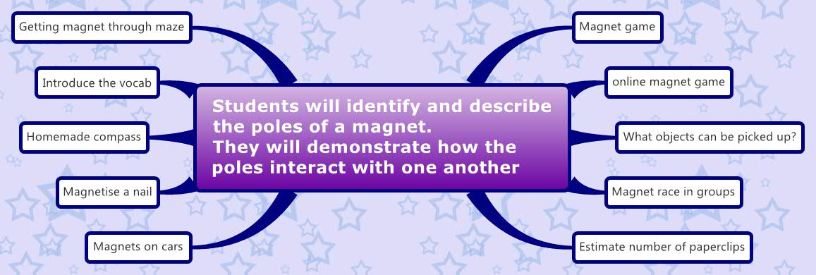
When creating lesson plans you need to keep your destination in mind. Where do you want students to end up? Write this goal as the main topic of your concept map and then brainstorm all the ideas you have for activities to use as stepping stones for your destination and plot these as sub topics for your map.

Step 2: Rationalise your Activities
Think of your class, consider the knowledge they already possess and the skills and concepts that they need to meet the main objective. Then read through your activities and rule out those that will not meet their needs.
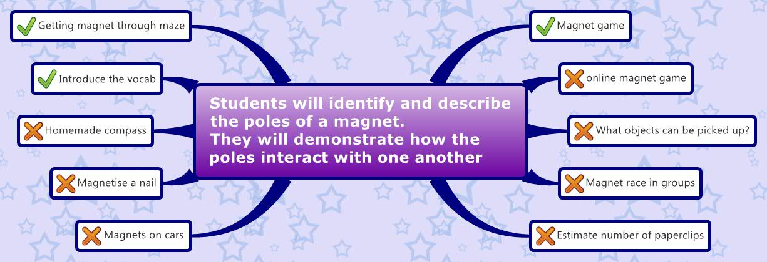

Step 3: Sequence your Activities
While sequencing your activities, consider how each one builds off another. Given the knowledge your students already have, will simpler activities work better at the start of the lesson? Will more complicated activities make clearer sense to students after some basic objectives have already been met?

Step 4: Rationalise your Activities Again
Look through your activities again, checking that they meet your objective and keeping in mind the time frame for each activity and the whole lesson.

Step 5: Plan your Transitions
Planning these ahead of time will help you create smoother transitions between activities and create a structured and coherent lesson plan where the students understand the reasons for the change of focus of the class and how it relates to the main objective for the lesson.
Write the transitions in your map, asking yourself about the significance of each activity and why you put them in that particular order. If you cannot answer those questions, you may need to go back to your first plan and consider alternative activities.

Step 6: Plan your Introduction
Introductions give students an indication of where the lesson is headed and connect concepts from earlier classes to the upcoming lesson. Also use them as checkpoints or reminders for yourself and your students - this is where we've been and this is where we're going.

Step 7: Plan your Conclusions
Conclusions reinforce important connections and help students anticipate the goals for the next class.
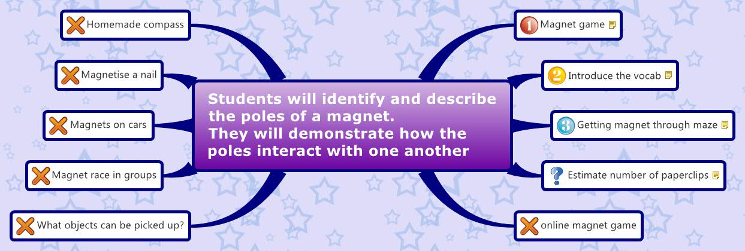

Step 8: Your final plan
Convert your concept map to a text format and transfer the detail to the format that your school prefers.

Sample Lesson Plan: Polarity of Magnets
Students will identify and describe the poles of a magnet.
They will demonstrate how the poles interact with one another
Magnet game
Tags: Priority 1
1. Have all the students stand in a circle facing the centre. Explain the rule that if they are facing the same direction they cannot touch each other. If they are facing in the opposite direction than their neighbours, then they need to make a connection and hold hands.
2. Have every other child turn around and face away from the centre. Ask if the students see any connections that can be made. Have every one face the front again.
3. Repeat the above exercise about three times. Each time use a different pattern of selecting children to face away from the centre. (2 in, 1 out) (3 in, 2 out) (etc.). After each selection, ask the students to look for connections that can be made.
4. Have children work in pairs. Assign pairs by telling them to work with the child who sits next to them in classroom. Give each child a magnet and have the pairs “play” with the magnets together. (Refer back to earlier activity) “Think about how your magnet acts with your partner’s magnet.”
A. “Do you notice anything interesting about how the magnets work together?” B. “Do the magnets like each other by going together, or do they act like they don’t want to be together?” “Anyone else notice anything?” C. “Do all of your magnets do that, or do just some of the magnets act that way?”
Introduce the vocab
Tags: Priority 2
1. “Why do you think the magnets are attracted to each other sometimes, and at other times they don’t want to go near each other?” (Listen to ideas from several students)
2. “We have some words that describe how the magnets are acting. You heard me say that the magnets are ATTRACTED to each other. What does it mean for magnets to be attracted to something?” “The opposite of attraction is called REPULSION, and that means that it pushes away.” Show two magnets being attracted to one another. “I can make the same two magnets show repulsion by turning one of them around like this.” “Every magnet has two POLES, a NORTH pole, and a SOUTH pole. The poles are on the ends of the magnets. Earlier, when I had you hold hands if you were facing in opposite directions, you were acting like magnets, and your hands were the poles. When you were the same, you couldn’t touch, and that is what happens with magnets. The poles have to be different for the poles of two magnets to touch. How many have ever heard the phrase OPPOSITES ATTRACT? That’s a very easy way to remember about magnets. The NORTH POLE always wants to be next to the SOUTH POLE because they are opposites.”
Getting magnet through maze
Tags: Priority 3
1. Pass out mazes. “I want each pair of students to think of a way to get one of your magnets to go through the maze by touching only the second magnet. Once the two of you decide on how to get through the maze, I want you to see if your method works. Your magnets cannot touch one another. As soon as you have figured out how to get through the maze, raise your hand, and either Ms. Lewis or myself will come over and you can show us how you did it.” Review the instructions by asking “What do I want you to figure out?” “What are you going to do after you’ve figured out a way to get through the maze?”
2. Once the students raise their hands and show how they get through the maze, ask questions about how they figured out what to do and why it worked. In their explanations, listen to see if they describe how the poles of a magnet work with and against one another.
Estimate number of paperclips
Tags: Question – extension activity if time
Compare the strength of the two poles of a magnet.
“Do you think one part of the magnet is stronger than the other parts of the magnet?” “Which part do you think will be stronger?” Spread paper clips on the table. Place the magnet on top of the paper clips, and then lift. “What parts of the magnet are the paper clips attracted to?” Count how many paper clips are stuck to each pole of the magnet. “Are there different amounts?” “What part of the magnet had fewer paper clips stuck to it?” “Does this tell you anything about the magnet?”
Online magnet game
Tags: No

What objects can be picked up?
Tags: No
Magnet race in groups
Tags: No
Magnets on cars
Tags: No
Magnetise a nail
Tags: No
Homemade compass
Tags: No

References
Allen, B. S., Hoffman, R. P., Kompella, J., & Sticht, T. G. (1993). Computer-based mapping for curriculum development. In: Proceedings of selected Research and Development Presentations Technology sponsored by the Research and Theory Division. New Orleans, LA. (Eric Document Reproduction Services No. ED 362 145)
Eide, Brock. L. & Eide, Fernette F. (2011) The Dyslexic Advantage: Unlocking the Hidden Potential of the Dyslexic Brain. London: Hay House UK Ltd.
Martin, D. J. (1994). Concept Mapping as an aid to lesson planning: A longitudinal study. Journal of Elementary Science Education, 6(2), 11-30

